
JAVA COUNTING CHANGE PROGRAM LAB REPORT

Name and Student ID: Jibran Akhter - 1073973
Date project completed: 02/25/2024
Platform (Mac, PC, Linux, etc.): Windows 11
Development system (onlineGDB, Eclipse, NetBeans): onlineGDB

OBJECTIVES
Enter and successfully run a C or C++ program
Use console input to read data from the keyboard
Calculate a total value for quarters, dimes, nickels and pennies
Use console output to display total with two digits past the decimal

PROJECT DESCRIPTION
Write a program that counts change. The program should ask for the number of quarters, the number of dimes, the number of nickels and the number of pennies. The program should then compute the value of all the coins and tell the user how much money there is, expressed in dollars and cents with two digits past the decimal point.
Display a title at the top of the screen when the program first runs. See a sample title message below. You must use constants for the value of each coin type. Multiply the number of each coin times the value for each coin using a constant for the value of each coin type. Refer to the PowerPoint or video on using the Paycheck program on how to organize the Counting Change program.

INPUT – PROCESS – OUTPUT TABLE
INPUTS | PROCESSING | OUTPUTS
quarters  dimes  nickels  pennies | Display Title message  Read quarters from keyboard  Read dimes from keyboard  Read nickels from keyboard  Read pennies from keyboard  Compute the total of all the coins  Display total | total

SAMPLE OUTPUT
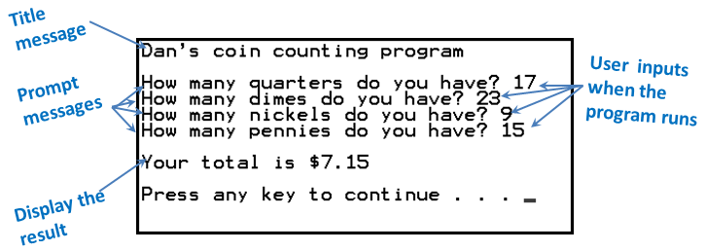
In this example, if you enter 17 for quarters, 23 for dimes, 9 for nickels and 15 for pennies, the program computes the total value of all your coins. The program then displays the total value of all the coins as $7.15.

TEST DATA TABLE
Fill in the Test Data Values and Expected Results as shown on the lab assignment.
Use the values shown on the first row of the table. Select your own test values for the next two
rows. You need to choose your test values and replace the ?? with your chosen test values
Fill in the Actual Results after you have run and tested your program
TEST DATA VALUES  Choose your test values. Replace each ?? with your choice | EXPECTED RESULT  Computed values before  the program is run | ACTUAL RESULT  Fill in the output displayed  by the program
Use these values  quarters = 9  dimes = 4  nickels = 6  pennies = 5 | Your total is $3.00 | 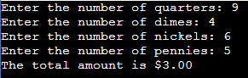
Choose your own values  quarters = ??  dimes = ??  nickels = 0  pennies = ?? | Your total is $0.96 | 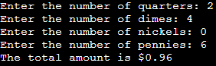
Use letters instead of numbers for the nickels  quarters = 0  dimes = 4  nickels = a  pennies = 6 | Please try again  Your total is $0.71 | 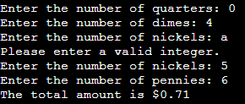

DISCUSSION
Complete the DISCUSSION section. It does not need to be long, but it needs to be complete.
What did you do to develop the program? ("Followed the Directions" is not a complete description
I used basic scanner objects to take users input and then I ensured that the program could handle exceptions such as letters. Added variables to calculate the total amount in dollars and cents with 2 decimal places.
What problems did you have and how did you overcome the problems?

I knew that I needed to incorporate the try-catch blocks in my program. I was just a little confused as to where I should put it. After a few tries I understood how to do it.

SCREENSHOTS
Capture only the portion of the screen that shows the calculator or program output. Do not capture the entire screen even though it may also contain the program output. If I need to zoom in on a screenshot, sometimes the image resolution is so poor that I am not able to read it. If this happens, I will ask that you resubmit your lab report. Refer to these instructions capturing screenshots and pasting them to the lab report

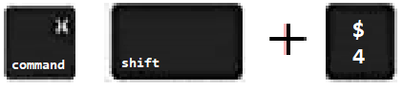
For the Mac
- hold down command + shift keys and press the 4 key
to get a screenshot of a selected area of the screen
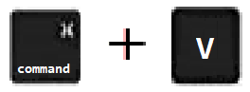
- Use the mouse or touchpad to select the desired area of the screen you want to save
- use command+V to paste into the lab report

For Windows
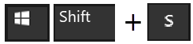
- use Microsoft's Snipping Tool by holding down the
Windows and Shift keys and tapping the ‘S’ key
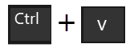
- Use the mouse or keypad to select the part of the screen you want to save
- use Ctrl+V to into the lab report.
Place your screenshots here
Show three screenshots showing each of the test conditions listed TEST DATA TABLE.
Screenshot #1
Screenshot #2
Screenshot #3

